

PIES - Data Modeling Design Document

Version 1.0
Nov 14, 2023

HotWax Systems Headquarters | Center of Engineering Expertise
@ Silicon Slopes  175 S. Main St, Suite 1310  Salt Lake City, Utah, 84111 USA  (877) 736-4080 | Plot No. 80, Scheme No 78, Part II  Vijay Nagar, Indore, M. P. 452010  0731-409-3684  WWW.HOTWAXSYSTEMS.COM
Table of Content
1. Introduction 3
1.1 Purpose 3
1.2 Scope 3
2. Schema Definition 3
2.1 Overview 3
2.2 Entity Definitions 3
2.2.1 Item 3
2.2.2 ProductAttribute 5
2.2.3 ExtendedProductInformation 7
2.2.4 Package 7
2.2.5 PartInterchange 9
2.2.6 ItemDescription 10
2.2.7 ItemDigitalAsset 11
2.2.8 Pricing 11
2.2.9 Kit Component 12
2.2.10 DigitalAsset 13
2.2.11 Description 15
2.2.12 MarketCopyContent (Header Level) 15
2.2.13 PriceSheet (Header Level) 16
3. Entity-Relationship (ER) Diagram 17
3.1 PIES Segments (Item Level) 17
3.2 PIES Codes 19
3.3 PriceSheet 19
3.4 ProductAttribute-Content Relationship 20
4. References 21
4.1 PIES XSD Schema 21
4.2 PIES Technical Documentation: 21
4.3 PIES Codes 21

1. Introduction

1.1 Purpose
The purpose of this document is to outline the data modeling design for the PIES import process, including the schema definition and the Entity-Relationship (ER) diagram.

1.2 Scope
This document covers the data model for the import process, detailing the structure of the database and the relationships between different entities.

This data model is built on PIES version 7.2 and is compatible with the PIES version 6.5 and above.

2. Schema Definition

2.1 Overview
We have utilized the PIES hierarchy to design a flexible data model. This will allow us to adapt and modify the model for future PIES specification versions and manage attribute translations.

2.2 Entity Definitions

2.2.1 Item

Item entity stores upper level item data of PIES Item: it is a root level entity having one to many relationships with entities of other segments ie Description, ExtendedProductInformation, ProductAttribute, Package, PartInterChange and DigitalAsset.

ItemID is a custom attribute which will serve as the primary key of the table uniquely identifying each Part of PIES data.

BrandAAAID will act as a foreign key (fk) to the Brands table and PartTerminologyID will serve as fk to the Parts table of PCdb.

Attributes:

- ItemID (string): primary key (autogenerated)
- MaintenanceType (string): Describes the maintenance type of the item.
- ItemLevelGTIN (string): Represents the item's GTIN .
- GTINQualifier: if “ItemLevelGTIN” is populated, then this attribute is required.
- PartNumber (string): Stores the part number of the item.
- BrandAAIAID (string): Contains the AAIA (Auto Care Association) ID for the brand.
- BrandLabel (string): Specifies the brand label.
- SubBrandAAIAID (string): Contains the AAIA (Auto Care Association) ID for the sub brand.
- SubBrandLabel (string): Specifies the brand label of the sub brand.
- .VMRSBrandId (string): a unique Brand identifier for all participating Heavy Duty parts manufacturer brands.
- ACESApplications (string): Stores ACES (Aftermarket Catalog Exchange Standard) applications.
- ItemQuantitySize (int): Represents the quantity size.
- ItemQuantitySizeUom (int): Uom of the itemQuantitySize field.
- MinimumOrderQuantity (int): Specifies the minimum order quantity.
- MinimumOrderQuantityUom (int): Uom of the MinimumOrderQuantity field.
- ContainerType(string): stores the ContainerType data.
- QuantityPerApplication: quantity used on a single vehicle or application, Value can also be zero or null.
- QuantityPerApplicationUom: Uom of the QuantityPerApplication field.
- QuantityPerApplicationQualifier: QuantityPerApplication qualifier.
- ItemEffectiveDate(date): Date the Item is available for purchase at the current price levels.
- AvailableDate: Date the Item is available for Sale.
- Group: Supplier Assigned Major Product Category.
- SubGroup: Supplier Assigned Minor Product Category.
- Unspsc: Universal Standard Product & Service Classification code
- AAIAProductCategoryCode (string): Contains the AAIA product category code.
- PartTerminologyID (string): Represents the part terminology ID.

Example:

<Item MaintenanceType="A">
<HazardousMaterialCode>Y</HazardousMaterialCode>
<BaseItemID>AB123YG</BaseItemID>
<ItemLevelGTIN GTINQualifier="UP">00123456789101</ItemLevelGTIN>
<PartNumber>AB12389</PartNumber>
<BrandAAIAID>BBBB</BrandAAIAID>
<BrandLabel>Wonderhose</BrandLabel>
<VMRSBrandID>FELPR</VMRSBrandID>
<QuantityPerApplication UOM="EA">2</QuantityPerApplication>
<ItemEffectiveDate>2006-08-13</ItemEffectiveDate>
<AvailableDate>2006-09-13</AvailableDate>
<MinimumOrderQuantity UOM="EA">2</MinimumOrderQuantity>
<ManufacturerProductCodes>
<Group>W12</Group>
<SubGroup>W123</SubGroup>
</ManufacturerProductCodes>
<AAIAProductCategoryCode>330102</AAIAProductCategoryCode>
<UNSPSC>11223344</UNSPSC>
<PartTerminologyID>55555</PartTerminologyID>
<VMRSCode>010456789</VMRSCode>
</Item>

2.2.2 ProductAttribute

ProductAttribute entity stores the data of Product Attribute Segment, which allows the sender of a PIES file to express either industry defined attributes from the Product Attribute Database (PAdb), or user defined attributes about an Item Part Number.

ProductAttributeID is the auto generated primary key and ItemID serves as fk to the Item entity. AttributeID represents the PartAttributeID from the PartAttributes table of PAdb.

The Content entity from OFBiz's Content model is utilized to store translations of Attribute data. The ContentID serves as a foreign key to the Content entity, storing data specific to a particular language. Through this approach, we can provide support for as many languages as needed.

Attributes:

- ProductAttributeID(string): primary key (autogenerated)
- ItemID (string): FK to Item entity
- ContentID: FK to Content entity
- AttributeID (string): Represents the attribute ID from PADB
- MaintenanceType (string): Describes the maintenance type of the attribute.
- PADBAttribute (boolean): Indicates whether it's a PADB (Product Attribute Database) attribute.
- RecordNumber (int): Specifies the record number.
- AttributeValue (string): Stores the attribute value.
- AttributeUOM (string): UOM of the attribute
- StyleID(string): This identifies the Style ID of the attribute if a Style Code exists for the PCdb Part Terminology being sent.
- MultiValueQuantity(String): how many multiple values for the attribute data are to be included as a total record.
- MultiValueSequence(string): Logical sequence of the multiple values being conveyed.
- LanguageCode(string): Override value for individual Segment Loop.
Example:

<ProductAttributes>
<ProductAttribute MaintenanceType="A" AttributeID="Length" PADBAttribute="N" AttributeUOM="IN" RecordNumber="1">12.5</ProductAttribute>
<ProductAttribute MaintenanceType="A" AttributeID="Width" PADBAttribute="N" AttributeUOM="IN" RecordNumber="2">4.25</ProductAttribute>
<ProductAttribute MaintenanceType="A" AttributeID="Height" PADBAttribute="N" AttributeUOM="IN" RecordNumber="3">3.5</ProductAttribute>
</ProductAttributes>

2.2.3 ExtendedProductInformation

ExtendedInformation entity stores the data of Extended Product Information Segment (EXPI). The EXPI Segment contains information ranging from “Country of Origin” to “Warranty Terms”.

ExtendedInformationID is the auto generated primary key and ItemID serves as fk to the Item table.

Attributes:

- ExtendedInformationID (string): primary key (autogenerated)
- ItemID (string): FK to Item entity
- EXPICode (string): Represents the code for extended product information.
- MaintenanceType (string): Describes the maintenance type of the extended information.
- ExtendedProductInformation (string): Stores the extended product information.
- LanguageCode (string): Stores the language code of the data.

Example:

<ExtendedInformation>
<ExtendedProductInformation MaintenanceType="A" LanguageCode="EN" EXPICode="CTO">US</ExtendedProductInformation>
<ExtendedProductInformation MaintenanceType="A" LanguageCode="EN" EXPICode="LIF">3</ExtendedProductInformation>
</ExtendedInformation>

2.2.4 Package

Each Package corresponds to a distinct “Package UOM”. This UOM identifies
the type of packaging that the data elements contain.

PackageID is the auto generated primary key and ItemID serves as fk to the Item table.

Attributes

- PackageID (string): primary key (autogenerated)
- ItemID (string): FK to Item entity
- MaintenanceType (string): Describes the maintenance type of the package.
- PackageUOM (string): Specifies the unit of measure for the package.
- PackageLevelGTIN: Global Trade Identification Number (GTIN) data for format PackageLevel
- ElectronicProductCode: Written form of RFID Code (Electronic Barcode).
- PackageUom: Identifies package level type.
- PackageBarCodeCharacters (string): Stores the barcode characters.
- QuantityofEaches (int): Represents the quantity of eaches in the package.
- MerchandisingHeight (decimal): Holds the height of the package.
- MerchandisingWidth (decimal): Stores the width of the package.
- MerchandisingLength (decimal): Specifies the length of the package.
- ShippingHeight (decimal): Shipping Height is the Vertical dimension (of Pack, Layer, Pallet, etc.). Put the product on its natural base.
- ShippingWidth (decimal)Shipping Width is the shorter of the left-to-right Horizontal dimensions of the product on a natural base.
- ShippingLength (decimal): Shipping Length is the longer of the left-to-right Horizontal dimensions of product on natural base.
- DimensionUom(string)
- Weights (decimal): Stores the weight of the package.
- WeightUom(string): Uom of weights data
- WeightVariance(string):Potential variance in package weight expressed as a percentage.
- StackingFactor: Indicates the number of pack levels the product may be safely stacked.

Example:

<Packages>
<Package MaintenanceType="A">
<PackageLevelGTIN>50055555000001</PackageLevelGTIN>
<PackageBarCodeCharacters>00555550000P10</PackageBarCodeCharacters>
<PackageUOM>EA</PackageUOM>
<QuantityofEaches>1</QuantityofEaches>
<Dimensions UOM="IN">
<MerchandisingHeight>3.9999</MerchandisingHeight>
<MerchandisingWidth>3.9999</MerchandisingWidth>
<MerchandisingLength>3.9999</MerchandisingLength>
<ShippingHeight>10</ShippingHeight>
<ShippingWidth>7</ShippingWidth>
<ShippingLength>5.25</ShippingLength>
</Dimensions>
<Weights UOM=" PG">
<Weight>8.9999</Weight>
<DimensionalWeight>.33</DimensionalWeight>
</Weights>
<WeightVariance>2.5</WeightVariance>
</Package>
</Packages>

2.2.5 PartInterchange

The Interchange Segment in PIES is used to store interchange data for
the Item Part Number in relation to alternative Brand Owner Part
Numbers.

PartInterchangeID is the auto generated primary key and ItemID serves as fk to the Item table.

Attributes

- PartInterchangeID (string): primary key (autogenerated)
- ItemID (string): FK to Item entity
- ItemIDTo(string) FK to the Item object of the Interchange.
- BrandAAIAID (string): Describes the BrandAAIAID of the Interchange Item.
- PartNumber (string): PartNumber of the Interchange Item.
- InterchangeQuantity (string): Quantity of the interchange equivalent to current Item.
- InterchangeQuantityUom(string): UOM the field InterchangeQuantity.
- ItemEquivalentUOM (int): UOM of interchange relationship.
- BrandLabel (string): Represents the BrandLabel of the Interchange item.
- SubBrandLabel (string): Represents the SubBrandLabel of the Interchange item.
- SubBrandAAIAID (int): SubBrandAAIAID.
- TypeCode (int): Specifies the type of Interchange.
- InternalNotes:
- InterchangeNotes:Comments which assist the
receiver in the interchange decision, such as differences in quality or components
- LanguageCode
- MaintenanceType

Example:

<PartInterchangeInfo>
<PartInterchange MaintenanceType="A" LanguageCode="EN" BrandAAIAID="CCCC" BrandLabel="Acme Parts" SubBrandAAIAID="CCCD " SubBrandLabel="Acme Extra" QualityGradeLevel="P" ItemEquivalentUOM="EA" InternalNotes="Internal Note">
<PartNumber InterchangeQuantity="1" UOM="EA" InterchangeNotes="Part Note">CC2000</PartNumber>
</PartInterchange>
<PartInterchange MaintenanceType="A" LanguageCode="EN" VMRSBrandID="FELPR" QualityGradeLevel="P" ItemEquivalentUOM="EA" InternalNotes="Internal Note">
<PartNumber InterchangeQuantity="1" UOM="EA" InterchangeNotes="Part Note">FEL100</PartNumber>
</PartInterchange>
</PartInterchangeInfo>

2.2.6 ItemDescription

ItemDescription is an association entity which associates the item to a certain description, ItemID + DescriptionId serves as the primary key of the entity.

Attributes

- DescriptionID (string): primary key (autogenerated) of the Descriptions Table
- ItemID (string): FK to Item entity

2.2.7 ItemDigitalAsset

ItemDigitalAsset is an association entity which associates one digitalAsset to a certain item, ItemID + DIgitalAssetID serves as the primary key of the entity.

Attributes

- DigitalAssetID (string): primary key (autogenerated) of the DigitalAsset Table
- ItemID (string): FK to Item entity

2.2.8 Pricing

The Pricing Segment stores different types of price sheets of the product. It takes “PriceType” as an attribute indicating what type of price the following child elements data relationship.

PricingID is the auto generated primary key and ItemID serves as fk to the Item table.

Attributes

- PricingID (string): primary key (autogenerated)
- ItemID (string): FK to Item entity
- PriceSheetNumber
- CurrencyCode
- EffectiveDate
- ExpirationDate
- Price
- PriceBreak
- PriceBreakUOM
- PriceType
- PriceTypeDescription
- PriceUOM
- PriceMultiplier
- PriceBreakQuantity
- PriceBreakQuantityUOM

Example:

<Pricing MaintenanceType="A" PriceType="AC1">
<PriceSheetNumber>2007WD</PriceSheetNumber>
<CurrencyCode>USD</CurrencyCode>
<EffectiveDate>2007-08-13</EffectiveDate>
<ExpirationDate>2008-08-13</ExpirationDate>
<Price UOM="EA">3.1415</Price>
<PriceBreak UOM="EA">String</PriceBreak>
</Pricing>

2.2.9 Kit Component

This segment contains child elements that define the component parts and supporting data.

Kits are defined as an assemblage of parts or equipment with the specific purpose of performing a full maintenance procedure or function) or a Set (a group or collection of things that belong together or resemble one another or are usually found together).

KitComponentID is the auto generated primary key and ItemID serves as fk to the Item table.

Attributes

- KitComponentID(string): primary key (autogenerated)
- ItemID (string): FK to Item entity
- ComponentPartNumber
- IDQualifier
- ComponentBrand
- ComponentBrandLabel
- ComponentSubBrand
- ComponentSubBrandLabel
- Description
- DescriptionCode
- QuantityInKit
- SequenceCode
- SoldSeperately

Example:

<KitComponent MaintenanceType="A">
<ComponentPartNumber IDQualifier="VC">HOS001</ComponentPartNumber>
<ComponentBrand>BFJK</ComponentBrand>
<ComponentBrandLabel>Acme Parts</ComponentBrandLabel>
<ComponentSubBrand>BFJS</ComponentSubBrand>
<ComponentSubBrandLabel>Acme
Extra</ComponentSubBrandLabel>
<Description DescriptionCode="DES" LanguageCode="EN">This is an example description for a
Component within a Kit.</Description>
<QuantityInKit UOM="EA">1</QuantityInKit>
<SequenceCode>1</SequenceCode>
<SoldSeparately>Y</SoldSeparately>
</KitComponent>

2.2.10 DigitalAsset

The Digital Asset Sub-Segment is used to relay information about any media types that support the related Item or Part.

The DigitalAsset entity is separate entity here as it is used for both item level as well as header level, Both use cases utilizes this entity to create a associate entity to join with the DigitalAsset eg. ItemDigitalAsset and MarketingCopyContentDigitalAsset.

Attributes:

- DigitalAssetID (string): primary key (autogenerated)
- MaintenanceType (string): Describes the maintenance type of the digital asset.
- AssetType (string): Represents the type of the asset.
- FileName (string): Contains the file name of the asset.
- Resolution (int): Specifies the resolution of the asset.
- AssetID (string): Represents the asset ID.
- FileType (string): Specifies the file type.
- FileSize (int): Stores the file size.
- AssetHeight (int): Specifies the height of the asset.
- AssetWidth (int): Stores the width of the asset.
- FilePath (string): Contains the file path of the asset.
- URI (string): Stores the URI (Uniform Resource Identifier) of the asset.
- Representation
- ColorMode
- Background
- OrientationView
- AssetDimensionUOM
- AssetDescriptions
- FilePath
- Duration
- DurationUOM
- Frame
- TotalFrames
- Plane
- Hemisphere
- Plunge
- TotalPlanes
- CountryCode

Example:

<DigitalAssets>
<DigitalFileInformation MaintenanceType="A" AssetID="xyz_BRO" LanguageCode="EN">
<FileName>xyz.jpg</FileName>
<AssetType>BRO</AssetType>
<FileType>JPG</FileType>
<Representation>A</Representation>
<FileSize>123456</FileSize>
<Resolution>72</Resolution>
<ColorMode>RGB</ColorMode>
<Background>WHI</Background>
<OrientationView>ANG</OrientationView>
<AssetDimensions UOM="PX">
<AssetHeight>250</AssetHeight>
<AssetWidth>250</AssetWidth>
</AssetDimensions>
</DigitalFileInformation>
</DigitalAssets>

2.2.11 Description

Description entity stores a particular type of description of the given Item (Part), DigitalAsset etc, DescriptionCode field differentiates different type of description related to the segment.

Attributes:

- DescriptionID (string): primary key (autogenerated)
- DescriptionCode (string): Represents the code for the description.
- LanguageCode (string): Stores the language code.
- MaintenanceType (string): Describes the maintenance type of the description.
- DescriptionText (string): Contains the description text.

Example:

<Descriptions>
<Description LanguageCode="EN" MaintenanceType="A" DescriptionCode="ABR" Sequence="1">String </Description>
</Descriptions>

2.2.12 MarketCopyContent (Header Level)

The Market Copy Segment is intended for expressing marketing and
descriptive copy that applies to many items, such as a product line or
series, or a Brand or Sub-Brand of product, or an entire company. Digital
Assets that relate to the Market Copy reference may be nested within the
Market Copy Segment.

Attributes:

- MarketCopyContetID(string): primary key (autogenerated)
- MarketCopyContent
- MarketCopyCode
- MarketCopyReference
- MarketCopySubCode
- MarketCopySubCodeReference
- RecordSequence
- MarketCopyType
- LanguageCode

Example:

<MarketCopyContent MaintenanceType="A" MarketCopyCode="PTI" MarketCopyReference="5562" MarketCopySubCode="PSG" MarketCopySubCodeReference="1234" RecordSequence="1" MarketCopyType="GCC" LanguageCode="EN">
</MarketCopyContent>

2.2.13 PriceSheet (Header Level)

The Price Sheet Header Segment is used to define zero to any number of
price sheets. This segment may correspond to printed paper price sheets,
or define digital only price sheets.

PriceSheetID is an auto generated primary key.

Attributes:

- PriceSheetID(string): primary key (autogenerated)
- MaintenanceType
- PriceSheetNumber
- PriceSheetName
- SupersededPriceSheetNumber
- CurrencyZone
- PriceZone
- EffectiveDate
- ExpirationDate

Example:

<PriceSheet MaintenanceType="A">
<PriceSheetNumber>2007WD</PriceSheetNumber>
<PriceSheetName>2007 WD Price</PriceSheetName>
<SupersededPriceSheetNumber>2006WD</SupersededPriceSheetNumber>
<CurrencyCode>USD</CurrencyCode>
<PriceZone>Western</PriceZone>
<EffectiveDate>2007-08-13</EffectiveDate>
<ExpirationDate>2008-08-13</ExpirationDate>
</PriceSheet>

3. Entity-Relationship (ER) Diagram

3.1 PIES Segments (Item Level)

Below ER diagram shows the relationship between different entities created to store the data of PIES segments. Item Entity is the root entity and represents the Item header level information. The ER diagram also consists of a MarketCopy entity which shares a common relationship in terms of DigitalAssets with the Item.

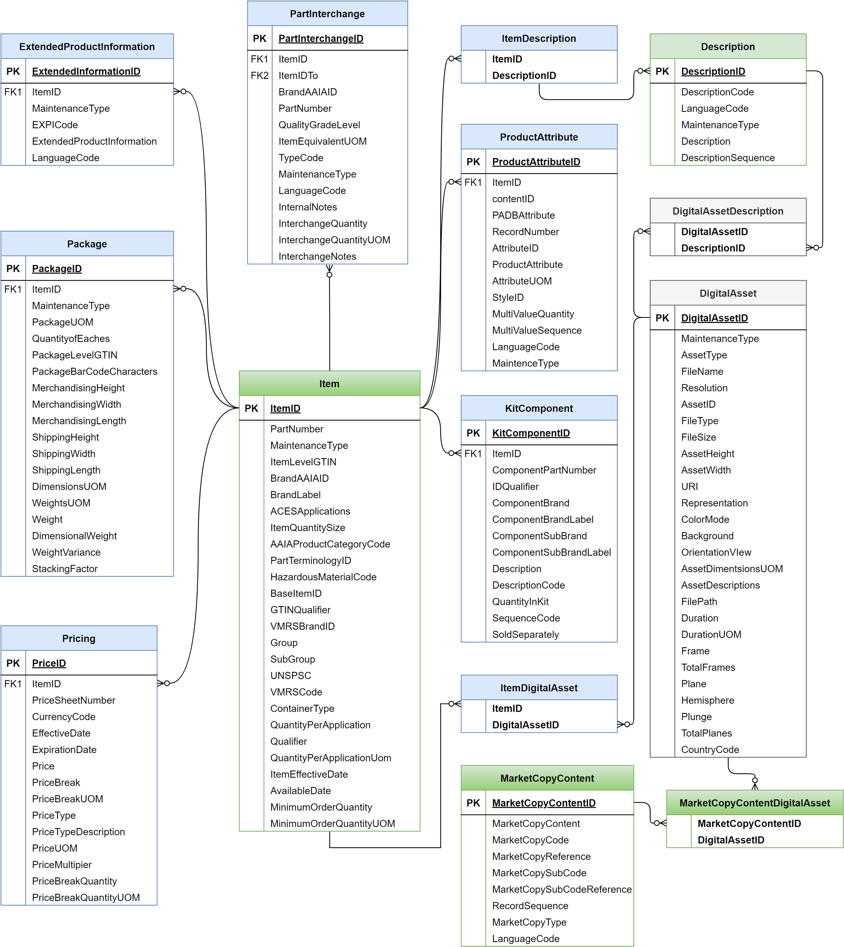

3.2 PIES Codes

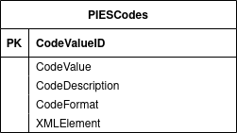

Example: Descriptions Segment and related PIES codes.

CodeValueID | CodeValue | CodeDescription | CodeFormat | XMLElement
C01 | DESC | Description Segment |  | <Descriptions>
C02 | DESC | Maintenance Type | ID1 | MaintenanceType
C05 | DESC | Description Code | ID3 | DescriptionCode
C10 | DESC | Description | Per table | <Description>

3.3 PriceSheet

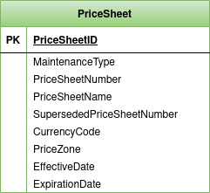

3.4 ProductAttribute-Content Relationship

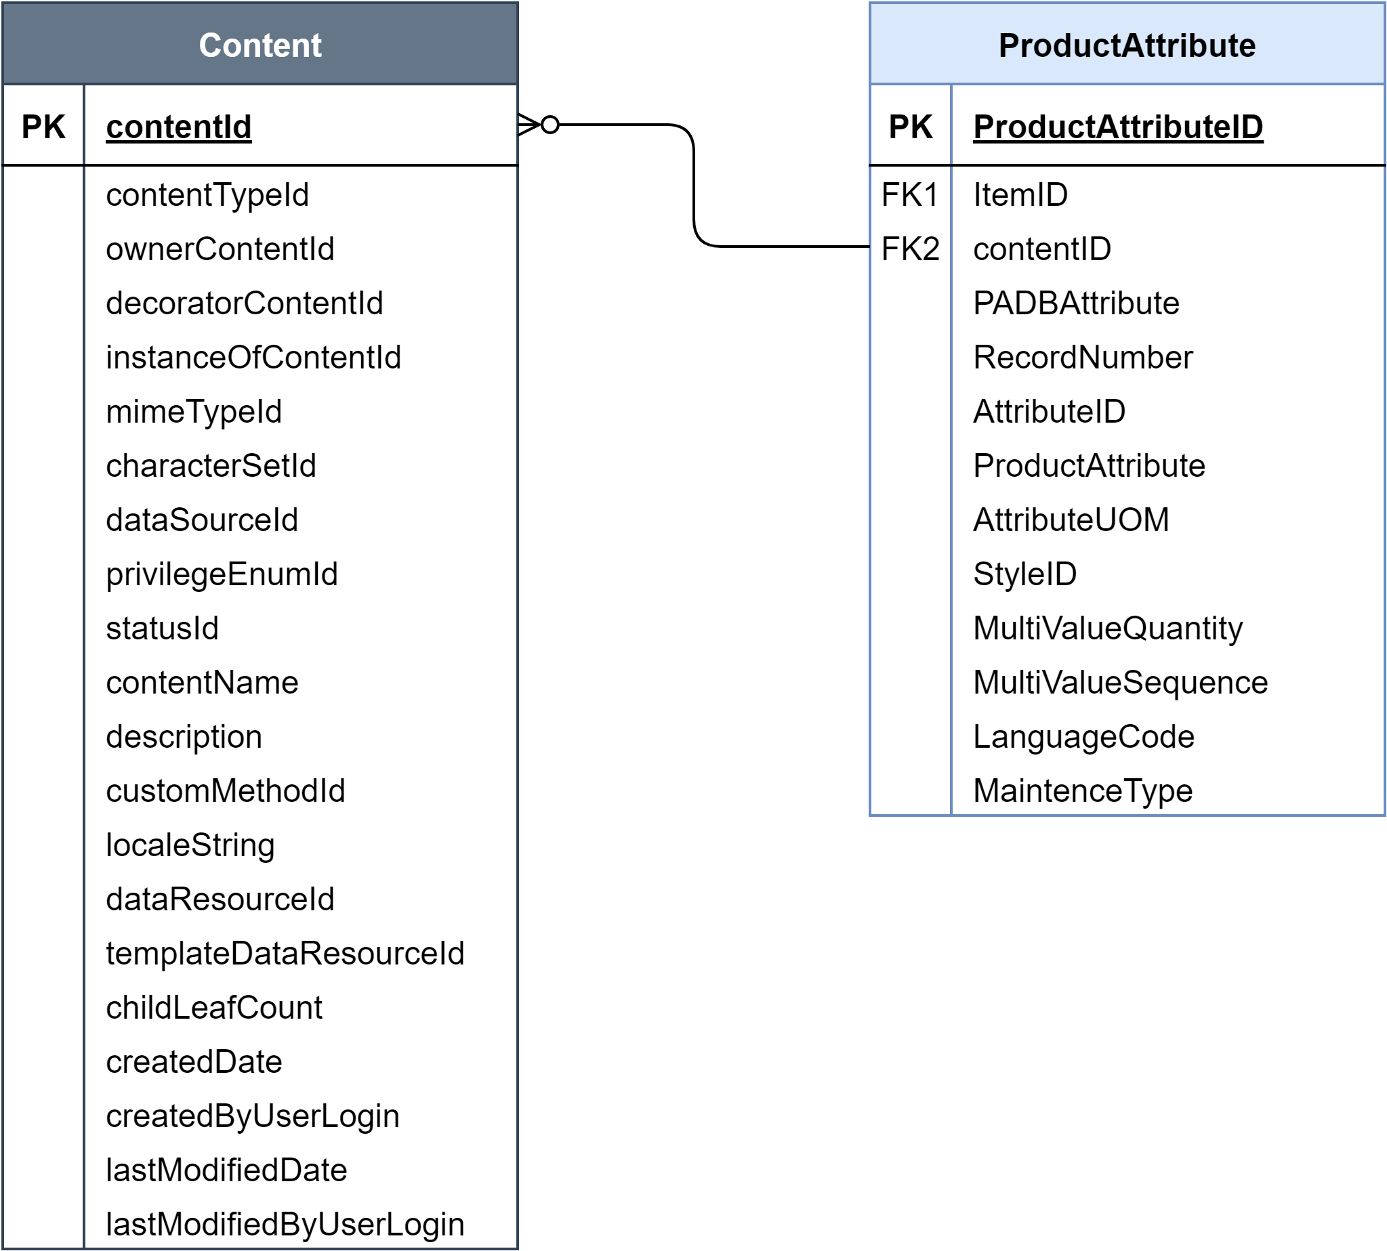

Color Schema

Header Entity

Item Entity

Description

DigitalAsset

Other

Ofbiz Entity

4. References

4.1 PIES XSD Schema
Here is the link to PIES XSD Schema, Version 7.1:
PIES_7_1_XSDSchema_rev3.xsd

4.2 PIES Technical Documentation:

Here is the link to PIES Technical Documentation, Version 7.2
PIES_7_2_TechnicalDocumentation_Rev6_5_4_2023.pdf

4.3 PIES Codes

Below table lists the PIES codes (Ref#) of the different PIES segments, subsegments and attributes.

PIES 7.1 - Rev2 - Auto Care Association - Product Information Exchange Standard
Ref # | Segment | Field Name | Format | XML Elements and Attributes
A01 | HEAD | Header Segment |  | <Header>
A02 | HEAD | PIES Version Number | ID3/5 | <PIESVersion>
A03 | HEAD | Submission Type | ID4/6 | <SubmissionType>
A05 | HEAD | Blanket Effective Date | D | <BlanketEffectiveDate>
A06 | HEAD | Changes Since Date | D | <ChangesSinceDate>
A10 | HEAD | Parent DUNS or DUNS+4 | ID9/13 | <ParentDUNSNumber>
A11 | HEAD | Parent GLN | ID13 | <ParentGLN>
A12 | HEAD | Parent VMRS ID | ID5 | <ParentVMRSID>
A13 | HEAD | Parent AAIAID | ID4 | <ParentAAIAID>
A20 | HEAD | BrandOwner DUNS or DUNS+4 | ID9/13 | <BrandOwnerDUNS>
A21 | HEAD | BrandOwner GLN | ID13 | <BrandOwnerGLN>
A22 | HEAD | BrandOwner VMRS ID | ID5 | <BrandOwnerVMRSID>
A23 | HEAD | BrandOwner AAIAID | ID4 | <BrandOwnerAAIAID>
A30 | HEAD | Buyer DUNS or DUNS+4 | ID9/13 | <BuyerDuns>
A35 | HEAD | Currency Code | ID3 | <CurrencyCode>
A37 | HEAD | Language Code | ID2 | <LanguageCode>
A40 | HEAD | Technical Contact Name | AN1/60 | <TechnicalContact>
A41 | HEAD | Contact Email | AN1/254 | <ContactEmail>
A42 | HEAD | PCdb Version Date | D | <PCdbVersionDate>
A43 | HEAD | PAdb Version Date | D | <PAdbVersionDate>
A50 | PRCS | Price Sheet Segment |  | <PriceSheet>
A51 | PRCS | Maintenance Type | ID1 | MaintenanceType
A52 | PRCS | Price Sheet Number | AN1/15 | <PriceSheetNumber>
A53 | PRCS | Price Sheet Name | AN1/30 | <PriceSheetName>
A55 | PRCS | Superseded Price Sheet Number | AN1/15 | <SupersededPriceSheetNumber>
A60 | PRCS | Currency Code | ID3 | <CurrencyCode>
A65 | PRCS | Price Zone | A 1/10 | <PriceZone>
A70 | PRCS | Price Sheet Level Effective Date | D | <EffectiveDate>
A75 | PRCS | Price Sheet Level Expiration Date | D | <ExpirationDate>
A80 | MKTC | Market Copy Segment |  | <MarketCopy>
A81 | MKTC | Maintenance Type | ID1 | MaintenanceType
A82 | MKTC | Market Copy Code | ID3 | MarketCopyCode
A83 | MKTC | Market Copy Code Reference | AN1/240 | MarketCopyReference
A84 | MKTC | Market Copy SubCode | ID3 | MarketCopySubCode
A85 | MKTC | Market Copy SubCode Reference | AN1/240 | MarketCopySubCodeReference
A86 | MKTC | Market Copy Type | ID3 | MarketCopyType
A87 | MKTC | Market Copy Content | per table | <MarketCopyContent>
A88 | MKTC | Record Sequence | N1/5 | RecordSequence
A89 | MKTC | Language Code | ID2 | LanguageCode
B01 | ITEM | Item Segment |  | <Items>
B02 | ITEM | Maintenance Type | ID1 | MaintenanceType
B03 | ITEM | Hazardous Material Code | ID1 | <HazardousMaterialCode>
B05 | ITEM | Base Item Number | AN1/48 | <BaseItemID>
B10 | ITEM | Item-Level GTIN | N14 | <ItemLevelGTIN>
B11 | ITEM | Item-Level GTIN Qualifier | ID2 | GTINQualifier
B15 | ITEM | Part Number | AN1/48 | <PartNumber>
B20 | ITEM | Brand AAIAID | ID4 | <BrandAAIAID>
B25 | ITEM | Brand Label | AN1/60 | <BrandLabel>
B27 | ITEM | SubBrand AAIAID | ID4 | <SubBrandAAIAID>
B28 | ITEM | SubBrand Label | AN1/60 | <SubBrandLabel>
B29 | ITEM | VMRS Brand ID | ID5 | <VMRSBrandID>
B30 | ITEM | ACES Applications | ID1 | <ACESApplications>
B32 | ITEM | Item Quantity Size | R1/8 | <ItemQuantitySize>
B33 | ITEM | Item Quantity Size UOM | ID2 | UOM
B34 | ITEM | Container Type | ID2 | <ContainerType>
B35 | ITEM | Quantity per Application Qualifier | ID3 | Qualifier
B40 | ITEM | Quantity per Application | AN0/8 | <QuantityPerApplication>
B41 | ITEM | Quantity per Application UOM | ID2 | UOM
B45 | ITEM | Item-Level Effective Date | D | <ItemEffectiveDate>
B50 | ITEM | Available Date | D | <AvailableDate>
B55 | ITEM | Minimum Order Quantity | N1/8 | <MinimumOrderQuantity>
B56 | ITEM | Minimum Order Quantity UOM | ID2 | UOM
B59 | ITEM | Manufacturer Product Codes |  | <ManufacturerProductCodes>
B60 | ITEM | Product Group Code | AN1/10 | <Group>
B61 | ITEM | Product Sub-Group Code | AN1/10 | <SubGroup>
B62 | ITEM | Product Category Code | ID6 | <AAIAProductCategoryCode>
B63 | ITEM | UNSPSC Code | ID8/10 | <UNSPSC>
B64 | ITEM | Part Terminology ID | ID4/5 | <PartTerminologyID>
B65 | ITEM | VMRS Code (Heavy Duty) | ID9 | <VMRSCode>
C01 | DESC | Description Segment |  | <Descriptions>
C02 | DESC | Maintenance Type | ID1 | MaintenanceType
C05 | DESC | Description Code | ID3 | DescriptionCode
C10 | DESC | Description | per table | <Description>
C15 | DESC | Language Code | ID2 | LanguageCode
C16 | DESC | Description Sequence | AN1/20 | Sequence
D01 | PRCE | Pricing Segment |  | <Pricing>
D02 | PRCE | Maintenance Type | ID1 | MaintenanceType
D05 | PRCE | Price Sheet Number | AN1/15 | <PriceSheetNumber>
D15 | PRCE | Currency Code | ID3 | <CurrencyCode>
D25 | PRCE | Price Sheet Level Effective Date | D | <EffectiveDate>
D30 | PRCE | Expiration Date | D | <ExpirationDate>
D35 | PRCE | Price Type | ID3 | PriceType
D36 | PRCE | Price Type Description | AN1/80 | <PriceTypeDescription>
D40 | PRCE | Price | N4-5/10 | <Price>
D41 | PRCE | Price UOM | ID2 | UOM
D42 | PRCE | Price Multiplier | N4-5/10 | <PriceMultiplier>
D45 | PRCE | Price Break Quantity | N1/8 | <PriceBreak>
D46 | PRCE | Price Break Quantity UOM | ID2 | UOM
E01 | EXPI | Extended Product Info Segment |  | <ExtendedInformation>
E02 | EXPI | Maintenance Type | ID1 | MaintenanceType
E05 | EXPI | EXPI Code | ID3 | EXPICode
E10 | EXPI | EXPI Data | per table | <ExtendedProductInformation>
E15 | EXPI | Language Code | ID2 | LanguageCode
F01 | ATRB | Product Attributes Segment |  | <ProductAttributes>
F02 | ATRB | Maintenance Type | ID1 | MaintenanceType
F05 | ATRB | Attribute ID (Type) | AN1/80 | AttributeID
F07 | ATRB | PADB Attribute | ID1 | PADBAttribute
F08 | ATRB | Attribute UOM | AN1/20 | AttributeUOM
F10 | ATRB | Attribute Data | AN1/2000 | <ProductAttribute>
F11 | ATRB | PADB StyleID | N1/5 | StyleID
F15 | ATRB | Record Number (Sequence) | N1/3 | RecordNumber
F17 | ATRB | Multi Value Quantity | N1/3 | MultiValueQuantity
F18 | ATRB | Multi Value Sequence | N1/3 | MultiValueSequence
F20 | ATRB | Language Code | ID2 | LanguageCode
H01 | PACK | Package Segment |  | <Package>
H02 | PACK | Maintenance Type | ID1 | MaintenanceType
H05 | PACK | Package Level GTIN | N14 | <PackageLevelGTIN>
H07 | PACK | Electronic Product Code | AN27 | <ElectronicProductCode>
H10 | PACK | Package Bar Code Characters | AN1/48 | <PackageBarCodeCharacters>
H15 | PACK | Package UOM | ID2 | <PackageUOM>
H20 | PACK | Quantity of Eaches in Package | N1/8 | <QuantityofEaches>
H21 | PACK | Inner Quantity | R1/8 | <InnerQuantity>
H22 | PACK | Inner Quantity UOM | ID2 | InnerQuantityUOM
H24 | PACK | Orderable Package | ID1 | <Orderable>
H25 | PACK | Merchandising Height | N4-5/8 | <MerchandisingHeight>
H30 | PACK | Merchandising Width | N4-5/8 | <MerchandisingWidth>
H35 | PACK | Merchandising Length | N4-5/8 | <MerchandisingLength>
H36 | PACK | ShippingHeight | N4-5/8 | <ShippingHeight>
H37 | PACK | ShippingWidth | N4-5/8 | <ShippingWidth>
H38 | PACK | Shipping Length | N4-5/8 | <ShippingLength>
H39 | PACK | Dimensions |  | <Dimensions>
H40 | PACK | UOM for Dimensions | ID2 | UOM
H44 | PACK | Weights |  | <Weights>
H45 | PACK | Weight | N4-5/9 | <Weight>
H46 | PACK | UOM for Weight | ID2 | UOM
H47 | PACK | Weight Variance (%) | R1/8 | <WeightVariance>
H50 | PACK | Dimensional Weight | R1/9 | <DimensionalWeight>
H55 | PACK | Stacking Factor | N1/3 | <StackingFactor>
J01 | HAZM | Hazardous Material Segment |  | <HazardousMaterial>
J02 | HAZM | Maintenance Type | ID1 | MaintenanceType
J04 | HAZM | Shipping Scope | ID3 | <ShippingScope>
J05 | HAZM | Bulk | ID1 | <Bulk>
J10 | HAZM | Regulating Country of Origin | ID2 | <RegulatingCountry>
J15 | HAZM | Transport Method | ID1 | <TransportMethod>
J20 | HAZM | Regulated | ID1 | <Regulated>
J25 | HAZM | Description | AN1/200 | <Description>
J31 | HAZM | Hazardous Material Code Qualifier | ID1 | <HazardousMaterialCodeQualifier>
J33 | HAZM | Hazardous Material Description | AN1/80 | <HazardousMaterialDescription>
J34 | HAZM | Hazardous Material Label Code | ID1/4 | <HazardousMaterialLabelCode>
J35 | HAZM | Shipping Name | AN1/260 | <ShippingName>
J40 | HAZM | UN/NA ID Code | ID6 | <UNNAIDCode>
J45 | HAZM | Hazardous Placard Notation | AN1/40 | <HazardousPlacardNotation>
J46 | HAZM | WHMIS Code | ID1/10 | <WHMISCode>
J47 | HAZM | WHMIS Free Text | AN1/80 | <WHMISFreeText>
J50 | HAZM | Packing Group Code | ID1/3 | <PackingGroupCode>
J55 | HAZM | Regulations Exemption Code | ID1/4 | <RegulationsExemptionCode>
J60 | HAZM | Text Message | AN1/2000 | <TextMessage>
J65 | HAZM | Outer Package Label | AN1/20 | <OuterPackageLabel>
J70 | HAZM | Language Code | ID2 | LanguageCode
K01 | KITS | Kit Segment |  | <Kits>
K02 | KITS | Maintenance Type | ID1 | MaintenanceType
K03 | KITS | Component Part Number | AN1/48 | <ComponentPartNumber>
K04 | KITS | Component Brand AAIAID | ID4 | <ComponentBrand>
K05 | KITS | Component Brand Label | AN1/60 | <ComponentBrandLabel>
K06 | KITS | Component SubBrand AAIAID | ID4 | <ComponentSubBrand>
K07 | KITS | Component SubBrand Label | AN1/60 | <ComponentSubBrandLabel>
K08 | KITS | Component ID Qualifier | ID2 | IDQualifier
K09 | KITS | Description Code | ID3 | DescriptionCode
K10 | KITS | Description | per table | <Description>
K11 | KITS | Component Part Terminology ID | ID4/8 | <ComponentPartTerminologyID>
K12 | KITS | Language Code | ID2 | LanguageCode
K15 | KITS | Quantity in Kit | N1/8 | <QuantityInKit>
K20 | KITS | Quantity UOM | ID2 | UOM
K30 | KITS | Sequence Code | N1/3 | <SequenceCode>
K31 | KITS | Sold Separately | ID1 | <SoldSeparately>
K35 | KITS | Kit Component |  | <KitComponent>
M01 | MKDA | Market Digital Assets Segment |  | <DigitalFileInformation>
M02 | MKDA | Maintenance Type | ID1 | MaintenanceType
M05 | MKDA | File Name | AN1/80 | <FileName>
M06 | MKDA | Asset ID | ID1/34 | AssetID
M10 | MKDA | Asset Type | ID3 | <AssetType>
M15 | MKDA | File Type | ID2/4 | <FileType>
M20 | MKDA | Representation | ID1 | <Representation>
M25 | MKDA | File Size | N1/10 | <FileSize>
M30 | MKDA | Resolution | ID2/4 | <Resolution>
M35 | MKDA | Color Mode | ID3 | <ColorMode>
M40 | MKDA | Background | ID3 | <Background>
M45 | MKDA | Orientation View | ID3 | <OrientationView>
M50 | MKDA | Asset Height | R1/6 | <AssetHeight>
M55 | MKDA | Asset Width | R1/6 | <AssetWidth>
M60 | MKDA | Asset Dimension UOM | ID2 | UOM
M64 | MKDA | Asset Descriptions |  | <AssetDescriptions>
M71 | MKDA | Asset Maintenance Type | ID1 | MaintenanceType
M72 | MKDA | Asset Description Code | ID3 | DescriptionCode
M73 | MKDA | Asset Description | per table | <Description>
M74 | MKDA | Asset Description Language Code | ID2 | LanguageCode
M75 | MKDA | File Path | AN1/80 | <FilePath>
M80 | MKDA | URI | AN1/2000 | <URI>
M81 | MKDA | Duration | N1/3 | <Duration>
M82 | MKDA | Duration UOM | ID2 | UOM
M83 | MKDA | Frame | N1/3 | <Frame>
M84 | MKDA | TotalFrames | N1/3 | <TotalFrames>
M85 | MKDA | Plane | N1/3 | <Plane>
M86 | MKDA | Hemisphere | ID1 | <Hemisphere>
M87 | MKDA | Plunge | R1/6 | <Plunge>
M88 | MKDA | TotalPlanes | N1/3 | <TotalPlanes>
M93 | MKDA | Asset Dates |  | <AssetDates>
M94 | MKDA | Asset Date | D | <AssetDate>
M95 | MKDA | Asset Date Type | ID3 | assetDateType
M98 | MKDA | Country | ID2 | <Country>
M99 | MKDA | Language Code | ID2 | LanguageCode
N01 | INTE | Part Interchange Segment |  | <PartInterchange>
N02 | INTE | Maintenance Type | ID1 | MaintenanceType
N10 | INTE | Brand AAIAID | ID4 | BrandAAIAID
N11 | INTE | Brand Label | AN1/60 | BrandLabel
N12 | INTE | SubBrand AAIAID | ID4 | SubBrandAAIAID
N13 | INTE | SubBrand Label | AN1/60 | SubBrandLabel
N14 | INTE | VMRS Brand ID | ID5 | VMRSBrandID
N16 | INTE | Item Equivalent UOM | ID2 | ItemEquivalentUOM
N20 | INTE | Interchange Part Number | AN1/48 | <PartNumber>
N21 | INTE | ReferenceItem | AN1/48 | ReferenceItem
N25 | INTE | Quality Grade Level | ID1 | QualityGradeLevel
N26 | INTE | Interchange Quantity | R1/8 | InterchangeQuantity
N27 | INTE | Interchange Quantity UOM | ID2 | UOM
N30 | INTE | Interchange Notes | AN1/240 | InterchangeNotes
N35 | INTE | Internal Notes | AN1/240 | InternalNotes
N40 | INTE | Language Code | ID2 | LanguageCode
P01 | ASST | Digital Assets Segment |  | <DigitalFileInformation>
P02 | ASST | Maintenance Type | ID1 | MaintenanceType
P05 | ASST | File Name | AN1/80 | <FileName>
P06 | ASST | Asset ID | ID1/34 | AssetID
P10 | ASST | Asset Type | ID3 | <AssetType>
P15 | ASST | File Type | ID2/4 | <FileType>
P20 | ASST | Representation | ID1 | <Representation>
P25 | ASST | File Size | N1/10 | <FileSize>
P30 | ASST | Resolution | ID2/4 | <Resolution>
P35 | ASST | Color Mode | ID3 | <ColorMode>
P40 | ASST | Background | ID3 | <Background>
P45 | ASST | Orientation View | ID3 | <OrientationView>
P50 | ASST | Asset Height | R1/6 | <AssetHeight>
P55 | ASST | Asset Width | R1/6 | <AssetWidth>
P60 | ASST | Asset Dimension UOM | ID2 | UOM
P64 | ASST | Asset Descriptions |  | <AssetDescriptions>
P71 | ASST | Asset Maintenance Type | ID1 | MaintenanceType
P72 | ASST | Asset Description Code | ID3 | DescriptionCode
P73 | ASST | Asset Description | per table | <Description>
P74 | ASST | Asset Description Language Code | ID2 | LanguageCode
P75 | ASST | File Path | AN1/80 | <FilePath>
P80 | ASST | URI | AN1/2000 | <URI>
P81 | ASST | Duration | N1/3 | <Duration>
P82 | ASST | Duration UOM | ID2 | UOM
P83 | ASST | Frame | N1/3 | <Frame>
P84 | ASST | TotalFrames | N1/3 | <TotalFrames>
P85 | ASST | Plane | N1/3 | <Plane>
P86 | ASST | Hemisphere | ID1 | <Hemisphere>
P87 | ASST | Plunge | R1/6 | <Plunge>
P88 | ASST | TotalPlanes | N1/3 | <TotalPlanes>
P93 | ASST | Asset Dates |  | <AssetDates>
P94 | ASST | Asset Date | D | <AssetDate>
P95 | ASST | Asset Date Type | ID3 | assetDateType
P98 | ASST | Country | ID2 | <Country>
P99 | ASST | Language Code | ID2 | LanguageCode
Z01 | STOP | Trailer Segment |  | <Trailer>
Z10 | STOP | Item Count | N1/7 | <ItemCount>
Z15 | STOP | Transaction Date | D | <TransactionDate>

